Zelika Anchipolovskaya

4/23/2018

Advanced Mobile Apps

Milestone 2

## Design

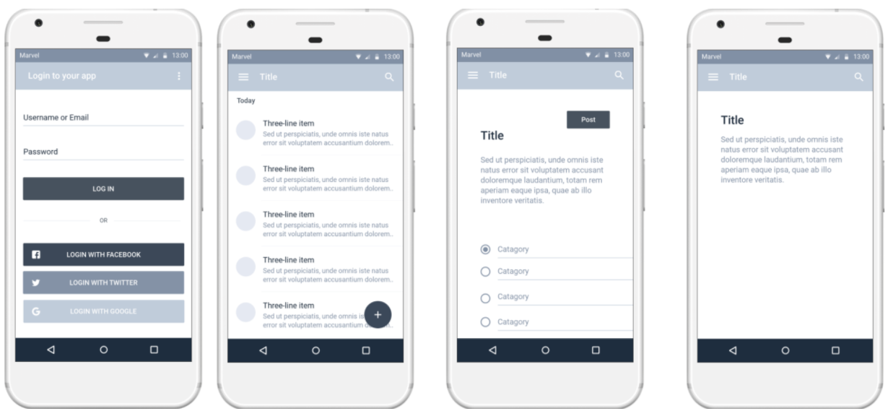

I created a [digital mock-up](https://marvelapp.com/cf569fe) of how the app will flow. This is the most simple version, where the user will sign in with Google to Firebase.

.

## Logo design

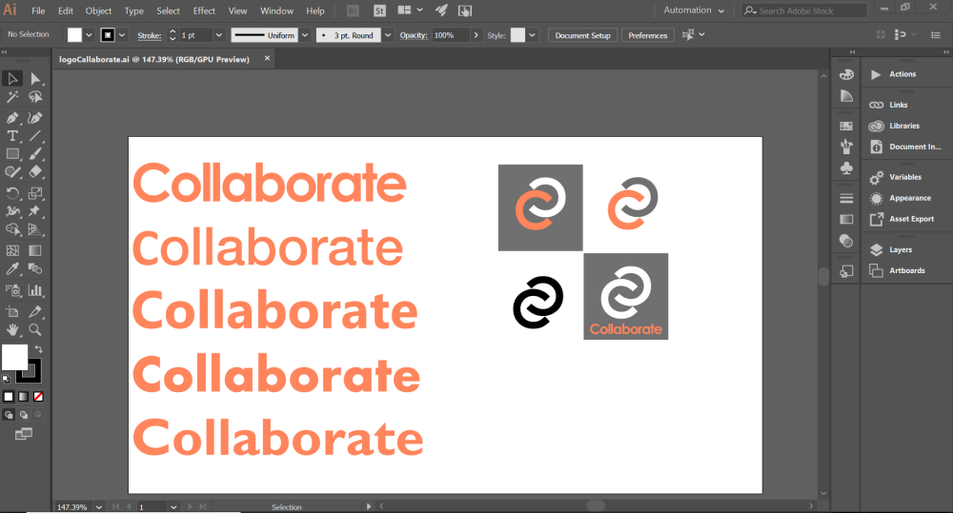

Using Illustrator I created the first version of the logo. I initially knew that the website was going to be mainly white and shades of grey. I decided to add an accent color so that the final design wouldn’t be too plain.

For the font, I liked the most was the first one, Century Gothic. I liked how the bold looked against the white color, and when I made the tracking closer together, the word still looked legible. I would love to change the word into something clever that represents the application as a whole.

For the graphic logo, I took the C from Collaborate and made them intertwine as if they are two hands that are shaking. This graphic needs some work. I’m not entirely set on the logo resembling an S, however, I like the simplicity.

## Data Model

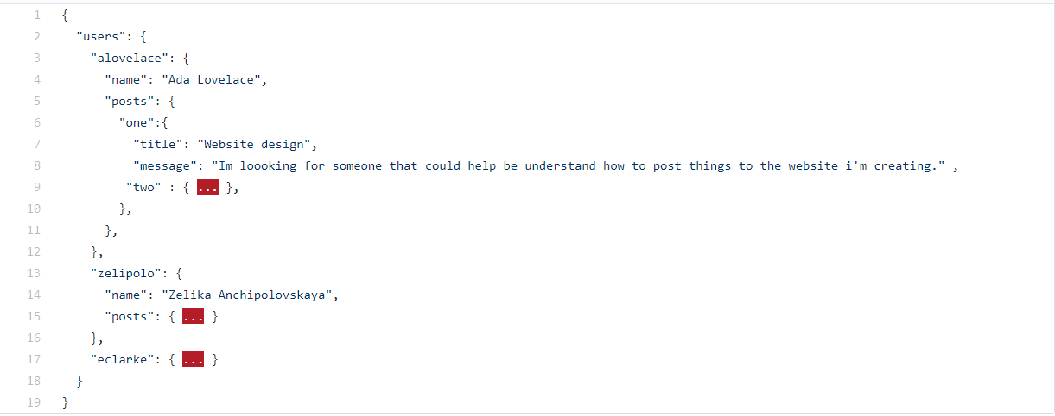

Looking at the Firebase website for suggested data models, I adapted the example they provided for a chat app. My data model is going to be an array of arrays.

## View Libraries/ Activities

I started research on using a recyclerView for my list in my main activity. However, although the internet suggests that it’s easier to use than listView I decided it’s not. I completed a tutorial for creating a recyclerView app and realized that this view is similar to list view because it uses adapters, but it’s customizable and therefore too advanced for me at this time. Instead I’ve decided to stick to the listView.

The tutorial that will be very help for me it the book app example which uses the basic view provided by Android Studio. I’m currently working on finishing that tutorial which uses Realm, I’ll be using Firebase instead, because I would like to use this database to store data from a website which will have the same concept behind it.

After finishing the book app lab then next helpful tutorial to complete will be the Firebase lab. Connecting these different concepts will help me better understand how to create the basic version of my own app.